Group Members:

Connor Kalina

Robert Corbett

Isabella Hilty

CAASI G2A Project Proposal

**Introduction**

The G2A Decision Support web application is intended to walk users through the steps of filing reports of police misconduct. The application will take information from the user anonymously. Once the user enters information pertaining to the location of the incident, the application will inform the user of what steps can be taken to file their complaint. The user will be able to find information about their city’s police union contract, especially problematic clauses that could block accountability. G2A hopes to be able to maintain a database of police union contracts for all departments in the United States and make this information more accessible to the broad population. We hope to make this application user friendly not just for the general population but also for the G2A volunteers who will be maintaining the application’s database.

Police union contracts block accountability mainly through six distinct categories of problematic clauses that are included in most police union contracts.

These include:

* Erasing misconduct records
* Giving officers unfair access to information
* Requiring city to pay for misconduct
* Restricting/Delaying Interrogations
* Limiting Oversight/Discipline
* Disqualifying Complaints

Our application will scrape police union contracts and identify problematic clauses that could block accountability. Identifying what contracts have these problematic clauses will allow the user of our application to know what will happen if they file a police misconduct form.

**User Stories:**

User 1

Location: Pittsburgh

Goal: Wants to find out if their name will be revealed if they file a police misconduct form.

Story: User enters website, goes to complaint information page. User enters Pittsburgh as their location. User selects “giving officers unfair access to information” in the dropdown box. Site returns information regarding what information officers will have available to them. This includes the clause that states that as of 2014, your name will be revealed to the police department when filing a complaint. The site will provide a link to Pittsburgh’s police complaint form.

User 2

Location: NYC

Goal: Wants to know if they can file a complaint a year after the occurrence.

Story: User 2 enters website, navigates to complaint information portal. User enters New York City as their location. In the dropdown box the user selects “Disqualifying Complaints”. The site returns information from the NYPD contract about how complaints are disqualified. This includes the clause that states that complaints will be disqualified if filed over 6 months after the occurrence.

The site will provide a link to NYC’s police complaint form.

User 3

Location: Chicago

Goal: Has no complaint, just wants to obtain information about their city’s police contract.

Story: User 3 enters website and navigates to police contract portal. User enters Chicago as location and submits. Site returns readable information regarding the Chicago PD’s contract.

**Communication Tools:**

* Discord
* Slack

**Language:**

We have chosen python as our main language because multiple members of the group have experience developing web apps in python and it suits the project's needs.

**Development Tools:**

* Git/Github for version control
* Visual Studio 2019
* Django
* HTML5, CSS 3, Javascript, Python
* Bootstrap
* Windows SQL Database

**Compatibility:** All modern web-browsers will be supported

**Development Method:** We will be using a Scrum methodology for development. Through a series of sprints, we will present the application to the G2A team and accept feedback from them as well as from community members. This feedback will allow us to build a tool that the G2A team members will be able to use and maintain in the future.

**Testing**: The test plan will test all functionality of the application, starting with unit tests of the backend and database, and finishing with black-box testing of the front-end user interface. Unit and integration testing will be done using the Django frameworks automated testing tools. Black-box testing of the entire application will be done using Selenium. All tests will be automated allowing for the application to be routinely tested quickly and easily during development.

**Customer Meetings:** Meetings with the customers will be held every Friday from 11AM to 12PM. During these meetings we will present progress and ask pivot the project based on their feedback.

**Roles:**

Robert Corbett: Software Quality Assurance/Testing

Isabella Hilty: Front-end Application designer/programmer

Connor Kalina: Back-end Application designer/programmer

**Data-Flow Diagram**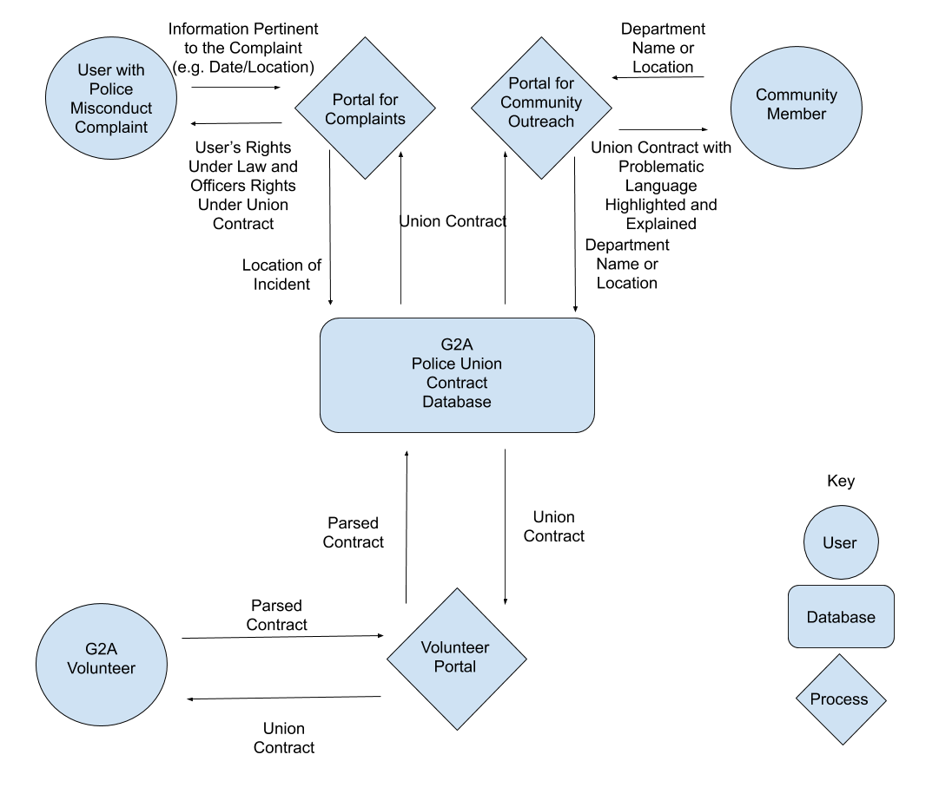

The application will have three main interfaces: one for users with specific misconduct complaints, one for community members interested in their local departments union contract, and one for the G2A team to add to and maintain the database.

The interface for specific complaints will take information pertinent to the incident and return information about what filing a complaint will entail and how they may file a complaint if they still wish to. The interface for community members will return the police union contract with sections highlighted and explanations of how these clauses may be problematic. Finally, the third interface will allow volunteers to parse the contracts and return them in a format that is easy for the users to understand.